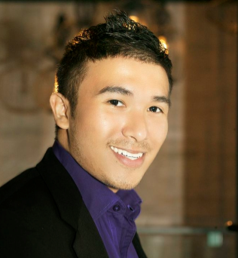

Lakhi Siap has more than 10 years of experience in multicultural & millennial media marketing, public relations and community outreach. He has consulted with high profile companies and organizations such as Pepsico, Mcdonald's, AT&T, and the United States Central Intelligence Agency (CIA) and the US State department. In 2016, Lakhi was awarded President Obama's Volunteer Service Award for Community Service and given the Distinguished Young Asian Professional Award by Asian Chronicle USA Cable Access TV. He was chosen by the former Philippine Ambassador to the US, Jose Cuisia Jr., to be part of the Filipino American Young Leaders Program (FYLPRO) in 2015. He is on the board and volunteers for numerous Asian American organizations throughout the Chicagoland area.